**System Requirements Specifications for Roadie**

Sponsor

**Electrical, Computer, Software & Systems Engineering at Embry-Riddle Aeronautical University**

Released 25 November 2014

**Are We There Yet?**

# **Revision History**

|  |  |  |
| --- | --- | --- |
| Date | Reason for Change | Version |
| 24 Nov 2014 | Use cases | 1.4.0 |
| 21 Nov 2014 | Block Diagrams | 1.3.0 |
| 20 Nov 2014 | State Diagrams Added | 1.2.0 |
| 18 Nov 2014 | Requirements Changes | 1.1.0 |
| 18 Sep 2014 | Requirements Level One | 1.0.0 |
| 15 Sep 2014 | Jorge Peer Review | 0.6.0 |
| 12 Sep. 2014 | Style Formatting | 0.5.0 |
| 12 Sep 2014 | Added Use Cases and Sequence Diagrams | 0.4.0 |
| 10 Sep 2014 | Added Overall Description | 0.3.0 |
| 9 Sep 2014 | In-class revision | 0.2.0 |
| 7 Sep 2014 | Initial Draft | 0.1.0 |

Table of Contents

**Revision History** ii

**1.** **Introduction** 1

**1.1** **Purpose** 1

**1.2** **Problem Statement** 1

**1.3** **Scope** 1

**1.4** **Team Information** 1

**1.5** **Overview** 1

**2.** **System State Definitions** 2

**2.1** **Coordination System State Diagram** 3

**3.** **Functional Decomposition of System** 4

**3.1** **High-Level Architecture of System** 4

**4.** **Decomposition of Coordination System** 5

**4.1** **Requirements** 7

**4.1.1** **Navigation** 7

**4.2** **Use Cases** 8

**4.2.1** **Use Case 1: Line Following** 8

**4.2.2** **Arrival at Challenge Zone** 10

**4.3** **Sequence Diagrams** 12

**4.4** **Traceability Matrix** 13

**5.** **Decomposition of Challenge System** 16

**5.1** Requirements 17

**5.2** Use Cases 18

**5.3** Traceability Matrix 26

**6.** **Decomposition of Movement System** 28

**6.1** Requirements 29

**6.2** Use Cases 29

**6.3** Traceability Matrix 37

**7.** **Appendix A** 39

**8.** **Glossary** 39

**9.** **Appendix B** 45

**9.1** **Competition Course** 45

**9.2** **Simon Carabiner** 46

**9.3** **Rubik’s Cube** 47

**9.4** **Pocket Etch-A-Sketch** 48

**9.5** **Playing Cards** 49

**9.6** **Scotch Blue Painter’s Tape** 50

**10.** **References** 51

Table of Figures

**Fig. 1**: State diagram for the Coordination System 3

**Fig. 2**: Division of Roadie into three subsystems. 4

**Fig. 3**: High level description of the systems in Roadie. 5

**Fig. 4**: Decomposition of coordination system for Roadie. 6

**Fig. 5**: Decomposition of Challenge System for Roadie. 16

**Fig. 6**: Decomposition of Movement System Roadie. 28

**Fig. 7** Competition course for SoutheastCon[1]. 45

**Fig. 8:** The exact Simon Carabiner to be used during competition [5]. 46

**Fig. 9:** The exact Rubik's Cube to be used during competition [6]. 47

**Fig. 10:** The exact pocket Etch-A-Sketch to be used during competition [7]. 48

**Fig. 11:** The exact playing cards to be used during competition [9]. 49

**Fig. 12:** The exact painter’s tape to be used on the course [8]. 50

# **Introduction**

## **Purpose**

The purpose of this document is to define the system requirements of Roadie, the robot put forth by team Are We There Yet (AWTY) to compete in the 2015 Institute of Electrical and Electronics Engineers (IEEE) SoutheastCon student hardware competition. These requirements include both functional requirements and non-functional requirements. This document is intended for the customer of AWTY, the requirements engineering team for AWTY, the design, testing and quality assurance teams, as well as all other teams involved in the development and construction.

## **Problem Statement**

To create an autonomous robot to compete in the 2015 IEEE SoutheastCon student hardware competition.

## **Scope**

Roadie is intended to compete in the 2015 IEEE Southeast Con student hardware competition. The system is envisioned to complete four unique challenges:

* Correctly play Simon for 15 seconds
* Draw “IEEE” on an Etch-A-Sketch
* Twist one row of a Rubik’s cube 180 degrees
* Pick up and carry one playing card across the finish line

Roadie system is intended to successfully complete the challenges outlined above within a time limit of five minutes.

Roadie is not intended to serve any other functions or fulfill any other purposes other than competing in the 2015 IEEE SoutheastCon competition.

## **Team Information**

|  |  |
| --- | --- |
| Name | Role |
| Brian Powell | Team Leader |
| Michael Philotoff | Software Manager |
| Alex Senopoulos | Developer |
| Brian Sterling | Hardware Manager |

## **Overview**

Section 1 of this document serves as an introduction to the system designed by AWTY. Section 2 provides a description and overview of the states the system can occupy. Section 3 includes the function decomposition of the system. Section 4 describes the decomposition of the Coordination system including the architecture, requirements, use cases, sequence diagrams and traceability matrix. Section 5 describes the decomposition of the Challenge system including the architecture, requirements, use cases, sequence diagrams and traceability matrix. Section 6 describes the decomposition of the Movement system including the architecture, requirements, use cases, sequence diagrams and traceability matrix.

The glossary contains definitions of all industry and standard terms as well as ambiguous terms used throughout this document. Appendix A includes the previous requirements that the L2 requirements were built upon. Appendix B includes a picture of the course as well as the challenges.

# **System State Definitions**

In order to better define transitions and states that the system will occupy, **Table 1** has been constructed, providing both the state name, and the description of the associated state.

|  |  |
| --- | --- |
| State Name | State Description |
| Approach | The state in which the system will be once it has entered a challenge area. The approach stage will consist of the system placing itself 4.2 cm ± 0.1 cm from the challenge. |
| Challenge Abortion | The state in which the system will enter upon incorrectly interacting with a challenge. When the system enters this state, it will immediately halt execution of the current challenge, exiting the challenge area and proceeding to the line following state. |
| Challenge Completion | The state in which the system will enter upon successfully completing a challenge. This system will remain in this state until exiting the challenge area. |
| Challenge Identification | The state in which the system attempts to identify the challenge it has arrived at. The system remains in this state until a positive identification. |
| Challenge Interaction | The state in which the system will attempt to complete a challenge. The system will remain in this state for as long as it is interacting with a challenge. |
| Challenge Misidentification | The state in which the system will enter upon falsely identifying the challenge it has arrived at. Should the system enter this state, this will represent a catastrophic failure. The system will proceed to the challenge abortion state. |
| Etch-A-Sketch | The state in which the system will attempt to complete the Etch-A-Sketch challenge. |
| Failed Approach | The state in which the system will enter upon stopping close than or further than 4.2 cm ± 0.1 cm. The system will proceed back to the approach state. |
| Finish | The state in which the system will enter upon crossing the finish line. The system will cease all movement. |
| Line Abandonment | The state in which the system will enter upon failing to proceed along the guidance tape. Should the system enter this state, the system will reverse direction to the last known location of the guidance tape. |
| Line Following | The state in which Roadie is following the Scotch Blue Painter’s tape located on the competition area. |
| Playing Card | The state in which the system will attempt to complete the playing card challenge. |
| Rubik’s Cube | The state in which the system will attempt to complete the Rubik’s Cube challenge. |
| Simon | The state in which the system will attempt to complete the Simon challenge. |
| Staging | The state in which the system commences operation. This state will last from the time the system is placed inside the starting area, until the LED in the starting area is turned off. |
| Zone Identification | The state in which the system will enter upon recognizing a challenge zone or finishing line. |
| Zone Misidentification | The state in which the system will enter upon failing to recognize a challenge zone. If the system were to enter this state, that would represent a catastrophic failure, resulting in termination of the round. |

**Table 1**: States that the system will occupy with their accompanying description.

By using **Table 1**, it was possible to construct the state diagrams shown in the sections below.

## **System State Diagram**

**Fig. 1** below shows the states that the system will be in, and how the system will transition from state to state.

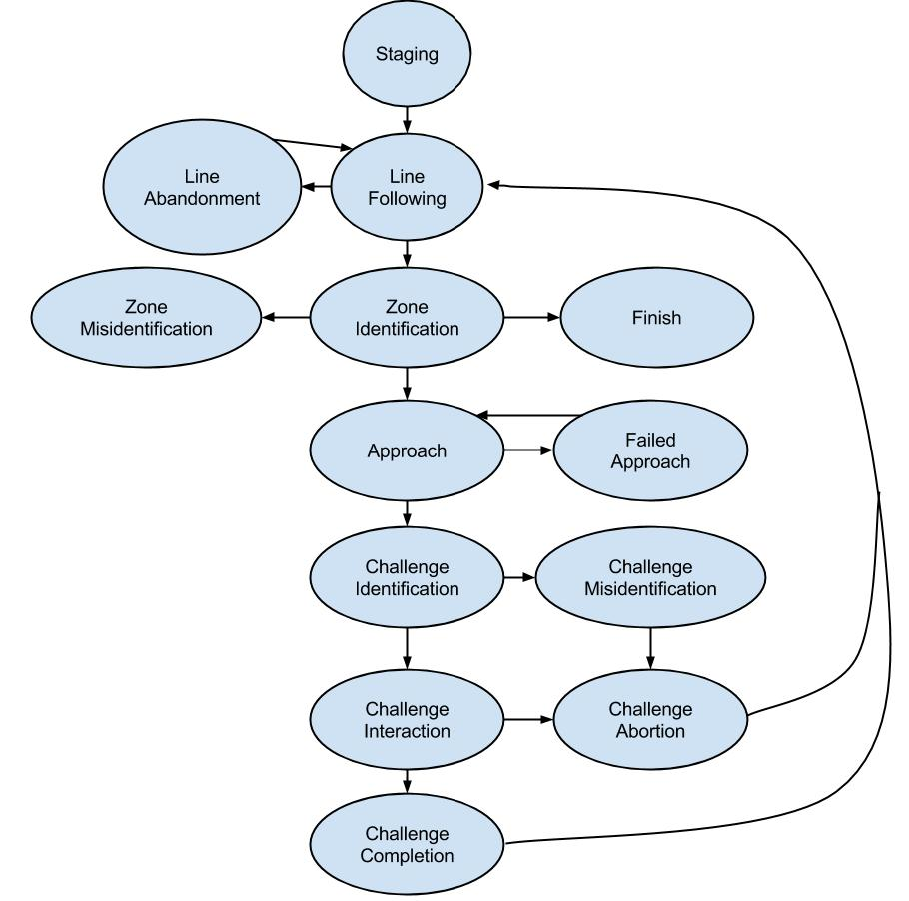

**Fig. 1**: State diagram for Roadie

# **Functional Decomposition of System**

Roadie is broken down three main subsystems: (1) the coordination system, (2) the challenge system and (3) the motion system. The division of these subsystems is illustrated in **Fig. 2**.

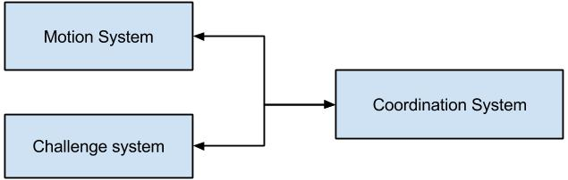

**Fig. 2**: Division of Roadie into three subsystems.

The communication and coordination subsystem relays information to both the arm subsystem and the movement subsystem. The components of Roadie were broken into systems based upon what other components they interacted with and what task they set out to perform. For example, all of the interactors for challenges (Simon, Etch-A-Sketch, Rubik’s cube and playing card), were divided into the Challenge System since the interactors represent the means through which Roadie will physically manipulate the challenges. The Coordination System encompasses the microcontrollers as well as the object detectors and line sensors. The reasoning behind such a decisions is that the object detectors and line sensors will send correction information that will be interpreted by the microcontroller to navigate the Roadie to the right challenge as well as identify the correct challenge upon arrival. The motion system is comprised of the motors and their associated wheels. This is due to the fact that the motors and wheels are responsible for moving the system to the intended destination.

These systems are further divided by functionality to create the high-level architecture as described in Sections 4,5 and 6.

## **High-Level Architecture of System**

The system architecture of Roadie is designed in a layered approach, depicted in **Fig*.* 3** below, in order to better divide the work being done and to aid in the conceptualization of the system design.

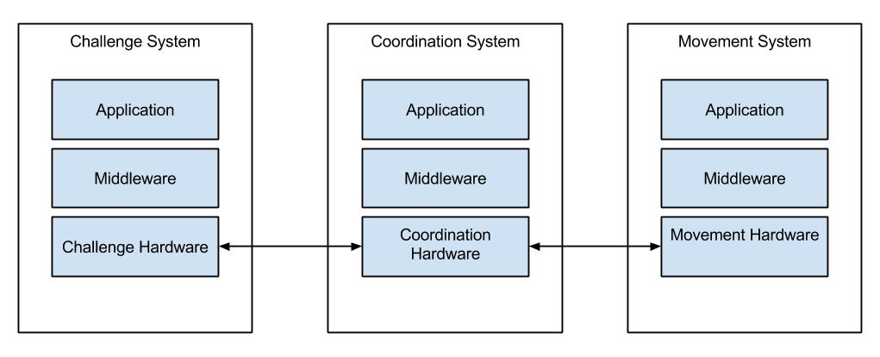

**Fig. 3**: High level description of the systems in Roadie.

The applications in the Coordination system represent feedback from the sensors (line and object detectors) which is translated by the middleware (software) to the physical communications means. From here, the Challenge system and the Motion system are directed by the Coordination system in order to navigate to challenges (Motion system) and complete the challenges (Challenge system). From there, middleware in the form of software is used to talk to the applications. In this instance, the application in the Challenge system represents the challenges (Simon Carabiner, pocket Etch-A-Sketch, Rubik’s cube, picking up a playing card), with the motion application being moving the whole system along the competition area. As Roadie progresses along, the Communication system constantly sends correction information to the Motion system as well as monitor the Motion system’s behavior to correct any anomalies.

# **Decomposition of Coordination System**

The architecture, requirements, use cases, sequence diagrams and requirements traceability matrix for the coordination system are included in this section.

## **Subsystem Architecture**

**Fig. 4** below, better illustrates the communications that occur amongst the systems in Roadie.

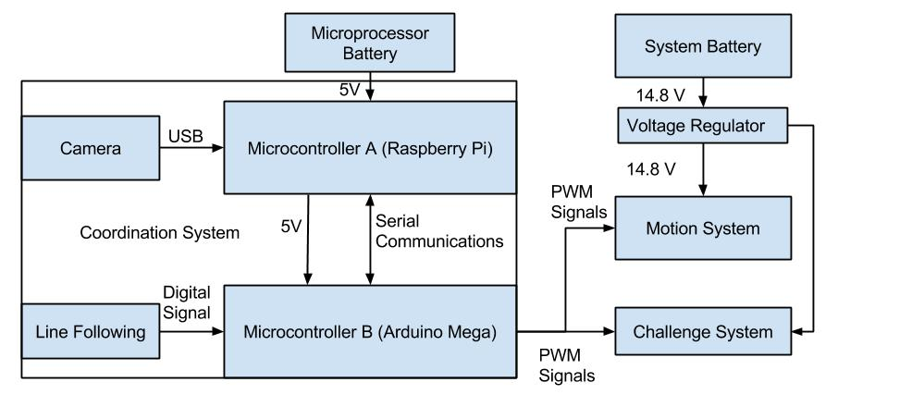

**Fig. 4**: Decomposition of coordination system for Roadie.

As depicted in **Fig. 4**, the Coordination System is composed of two microcontrollers, both communicating with each other over a serial interface. The Arduino Mega is the primary micro controller, interpreting inputs from the reflectance array (line following) and issuing commands based on values received.

The coordination system is responsible for the navigation and challenge identification process of Roadie. The system consist of object detection, line following, and subsystem coordination.

Object detection allows Roadie to identify what object it has arrived at. By using object detection, Roadie will be able to determine what challenge needs to be completed as well as how to align with the challenge.

Line following allows Roadie to traverse the competition area. Roadie will use it’s line following capabilities to navigate from the starting area to the various game stations.

Subsystem coordination allows Roadie to know what each subsystem is doing at any given moment. This will aide in ensuring that Roadie will successfully complete all tasks.

### **Assumptions**

During operation, it is assumed that Roadie will begin with sufficient battery to complete the course. If the system is started with a battery that is not charged enough, the system will not be able to successfully complete the course.

It is also assumed that Roadie will be operating in the competition area shown in **Fig. 7**, and only the competition area shown in aforementioned figure. Since Roadie has been designed to compete in IEEE Southeast Con 2015, any course modifications will render the system inoperable. Furthermore, it is assumed that the course will be free of obstructions and obstacles. Any obstacles will prevent Roadie from completing the course. Assumptions have also been made regarding the course construction. It is assumed that the course will be constructed according to the methods and materials outlined in [1].

The object detection in the Coordination system will only operate on the challenges outlined in [1]. Any modifications to the challenges or any different items introduced into the challenge area will create a problem for Roadie.

Assumptions have been made regarding the subsystem coordination. If one of the subsystems gives throws an unexpected error, or an error that the master controller is not prepared for, the entire system will fail.

### **Dependencies**

The coordination system depends on the challenge system and movement system to relay information back to it so that it may guide Roadie in course completion. If this connection is broken or fails, Roadie will ultimately fail.

Problems arising from dependencies include any mechanical failure which would render the system inoperable. Furthermore, electrical issues or corrupted data will cause the system to fail the competition round.

### **Constraints**

The coordination system is constrained by the clock speed of the selected microcontroller as well as the interfaces through which the other subsystems will communicate. The system is also constrained by the rules and regulations laid forth in [1].All code and logic in the Coordination system must fit within the system memory of the microcontrollers.

## **Requirements**

This section details the requirements placed on the coordination system. They include requirements on the navigation, ability to identify challenges and hardware requirements for the system.

### **Navigation**

COR 1. The system shall commence operation from the starting area.

COR 2. The system shall progress forward along the Scotch Blue Painter’s tape (guidance tape) until reaching a challenge zone or reaching the finish line.

COR 3 The system shall continuously adjust alignment relative to the guidance tape.

COR 4 The system shall identify the challenge zone upon arrival.

COR 4.1 The system shall enter the approach state.

COR 4.2 The system shall enter the challenge identification state upon exiting the approach state

COR 4.3 Upon completing the challenge, the system shall exit the challenge zone, continuing back to the line following state.

COR 5 The system shall wait for the red LED in the starting area to turn off before exiting the starting area.

### **Challenge Identification**

COR 6 The system shall correctly identify the challenge within 10 seconds of arrival in a challenge zone

COR 6.1 The system shall correctly identify the challenge within 5 seconds of entering the challenge identifications state.

COR 6.2 The system shall correctly identify the Simon Carabiner depicted in **Fig. 8**.

COR 6.3 The system shall correctly identify the Rubik’s Cube depicted in **Fig. 9**

COR 6.4 The system shall correctly identify the pocket Etch-A-Sketch depicted in **Fig. 10**

COR 6.5 The system shall correctly identify the playing cards depicted in **Fig. 11**

COR 7 The system shall determine the center of the challenge relative to the center of the leading edge of the chassis.

COR 7.1 The system shall align with the challenge if the challenge is not within 0.1 cm of the center of the leading edge of the chassis

### **Hardware**

COR 8 The system shall possess at least two USB ports

COR 9 The system shall possess the ability to communicate with a remote PC wirelessly

COR 10 The system shall possess the ability to run computer vision software.

COR 11 The system shall possess the ability to generate pulse width modulation signals.

COR 12 The system shall be completely autonomous after being powered on.

COR 13 The system shall operate for a minimum of 30 minutes when the power source starts with a full charge.

## **Use Cases**

The following use cases demonstrate the intended operations of the Coordination system of Roadie. The use cases outline the intended sequence of events as well as the procedures that will be followed in the event of a system failure.

Note: “*” indicates at any given time, during the use case.

### **4.3.1** **Use Case 1: Line Following**

Scope: Roadie

Level: User goal

Primary Actors: Roadie

**Stakeholders & Interests**

* **Team AWTY** - as the development team for Roadie, Roadie’s performance in the challenge will reflect directly back upon them.
* **Dr. Barott, Dr. Seker and Mr. Jorge Torres –** as customers of Team AWTY, there is an expectation that Roadie will compete successfully in the challenge.
* **ERAU –** the system represents the quality of the education at the University as well as the technical ability of the sponsors and the department.
* **ECSSE Department –** direct sponsor of Team AWTY expects Roadie to compete in and complete the challenge to the best of its abilities.
* **IEEE –** competition sponsor expects Team AWTY to conduct themselves in a manner befitting of a professional organization as well as to demonstrate innovate solutions to technical challenges.

**Preconditions**

* Roadie has been placed in the 1 ft. x 1 ft. starting area on the competition area.
* Roadie has been turned to the on position.

**Postconditions**

* Roadie crosses the finish line.

**Main Success Scenario**

1. Roadie waits for the red LED to turn off before entering into the Line Following State.
2. Roadie enters into the Line Following State and starts line following making turns based on which way the line is turning until reaching the first challenge.
3. After completing the first challenge, Roadie turns around and begins to line follow until reaching the second challenge.
4. After completing the second challenge, Roadie turns around and beings to line follow until reaching the third challenge.
5. After completing the third challenge, Roadie turns around and beings to line follow until reaching the fourth challenge.
6. After completing the fourth challenge, Roadie turns around and beings to line follow until crossing the finish line.

**Extensions (Alternate Flows)**

*a. Roadie is no longer following the guidance tape.

1. Roadie will enter the line abandonment state.

*b. Roadie has failed to identify a challenge zone.

1. Roadie will enter the zone misidentification state.

**Frequency of Occurrence**

This use case will occur each time the system is placed within the 1 ft. x 1 ft. white square. During the competition this shall occur three times due to there being three rounds for each robot that is entered.

### **4.3.2** **Use Case 2: Arrival at Challenge Zone**

Scope: Roadie

Level: User goal

Primary Actors: Roadie

**Stakeholders & Interests**

* **Team AWTY** - as the development team for Roadie, Roadie’s performance in the challenge will reflect directly back upon them.
* **Dr. Barott, Dr. Seker and Mr. Jorge Torres –** as customers of Team AWTY, there is an expectation that Roadie will compete successfully in the challenge.
* **ERAU –** the system represents the quality of the education at the University as well as the technical ability of the sponsors and the department.
* **ECSSE Department –** direct sponsor of Team AWTY expects Roadie to compete in and complete the challenge to the best of its abilities.
* **IEEE –** competition sponsor expects Team AWTY to conduct themselves in a manner befitting of a professional organization as well as to demonstrate innovate solutions to technical challenges.

**Preconditions**

* Roadie has reached a challenge zone.

**Postconditions**

* Roadie has correctly identified what challenge zone it has arrived at.

**Main Success Scenario**

1. Roadie correctly detects it has arrived at a challenge zone.
2. Roadie begins to approaches the object.
3. Roadie halts movement at 4.2 cm ± 0.1 cm from the challenge.
4. Roadie correctly initiates the challenge detection process.
5. Roadie correctly identifies the challenge it has arrived at within 5 seconds of initiating the challenge detection process.
6. Roadie determines the alignment of the challenge relative to the leading edge of the chassis.
7. Roadie correctly determines the direction and distance to move laterally (left or right) to align with the challenge.
8. Roadie repeats steps 6 and 7 until it is aligned within 0.1 cm of the leading edge of the chassis.
9. Roadie enters a challenge interaction state.

**Extensions (Alternate Flows)**

*a. Roadie fails to correctly detects it has arrived at a challenge zone.

1. Roadie will enter the zone misidentification state.

*b. Roadie fails to halt movement at 4.2 cm ± 0.1 cm from the challenge.

1. Roadie will proceed to the failed approach state

*d. Roadie fails to correctly detect the challenge.

1. Roadie will proceed to the challenge misidentification state

*e. Roadie fails to correctly identify the challenge within 5 seconds of initiating the challenge identification state.

1. Roadie will continue to attempt to identify the object for another 25 seconds. If Roadie is still unsuccessful, Roadie will proceed to the challenge misidentification state.

**Frequency of Occurrence**

This use case will occur every time Roadie reaches a challenge zone. During the competition this shall occur four times due to there being four challenge zones on the competition area.

## **Sequence Diagrams**

The following sequence diagrams demonstrate the sequence of events Roadie shall take in order to complete the Coordination System use cases.

## **Use Case 1: Line Following**

For the Use Case: Line Following as shown in **Fig. 5** below shows how Roadie will communicate with the movement system to navigate the course between challenge zones, crossing the finish life after completing the last challenge zone..

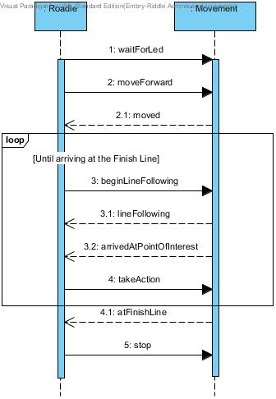

**Fig. 5:** Use Case: Line Following Sequence Diagram

## **Use Case 2**

For the Use Case: Arrival at Challenge Zone Sequence Diagram as shown in **Fig. 6** below shows how Roadie will communicate with the Coordination system to identify the challenge, align to the challenge and complete the challenge.

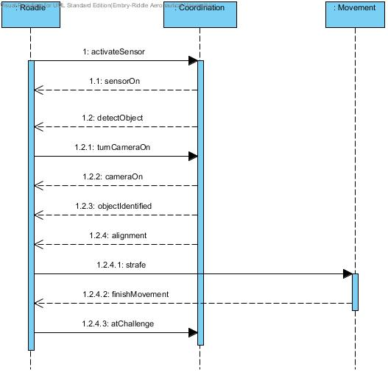

**Fig. 6:** Use Case: Arrival at Challenge Zone Sequence Diagram

## **Traceability Matrix**

The requirements traceability for the Coordination system is shown in **Table 2** below.

|  |  |  |  |
| --- | --- | --- | --- |
| Previous Requirement Number | Previous Requirement Text | New Requirement Number | Fulfillment Justification |
| 3.2.1 | The system shall start in the starting area | COR 1 | The new requirement is able to fulfill the previous L1 requirement as it is simply an extension of the previous L1 requirement. The new requirement has been refined so that the operation being performed in the starting area is less vague. |
| 3.2.2 | The system shall progress forward along the blue guidance tape until reaching a challenge area or reaching the finish line. | COR 2 | This requirement has not been changed from the previous version. |
| New | Did not exist previously | COR 3 | This requirement has been added to specify how the system shall orient itself about the guidance tape. |
| 3.2.3 | The system shall identify the challenge zone and stop movement upon arrival. | COR 4 , COR 4.1, COR 4.2, COR 4.3 | The previous requirement implied that the system would halt all movement once entering a challenge zone. Since there are four challenge zones in the competition area, this requirement needed to be refined. As such, the original requirement has been split into three different requirements, each detailing what is required of the system upon arriving in a challenge area. |
| 3.1.7 | The system shall wait for red [RGB value TBD] LED in starting area to turn off before exiting the starting area. | COR 5 | The previous requirement attempted to constrain the system to a specific color range which lends more towards a design choice. |
| 3.3.1 | The system shall correctly identify the challenge upon arrival. | COR 6 | The previous requirement has had a time value added to it to impose a performance characteristic on the system. This will aid in completing the course within the allotted time. |
| New | Did not exist previously | COR 6.1 | The addition of this requirement ensures that the system will be able to swiftly identify the challenges. Additionally, it reduces the amount of time the system will be on the competition area. |
| 3.3.1.1 | The system shall correctly identify the Simon Carabiner depicted in **Fig. 8**. | COR 6.2 | This requirement has not been changed from the previous version. |
| 3.3.1.2 | The system shall correctly identify the Rubik’s Cube depicted in **Fig. 9.** | COR 6.3 | This requirement has not been changed from the previous version. |
| 3.3.1.3 | The system shall correctly identify the pocket Etch-A-Sketch depicted in **Fig. 10**. | COR 6.4 | This requirement has not been changed from the previous version. |
| 3.3.1.4 | The system shall correctly identify the playing cards depicted in **Fig.** [TBD]. | COR 6.5 | With the specification of the card type, this requirement has been refined to include the specific card being used. |
| 3.3.2 | The system shall align with the challenge before attempting to complete the challenge. | COR 7, COR 7.1 | The previous requirement did not account for the possibility that the system may already be aligned with the challenge. As such, it has been broken into two separate requirements, one dealing with the instance in which the system is already aligned, the other dealing with the case in which the system is not aligned. |
| New | Did not exist previously | COR 8 | This new requirement ensures that the system will be able to interface with multiple USB devices, lending to various designs. |
| New | Did not exist previously | COR 9 | This new requirement ensures that the system will always be able to transmit information to a remote machine to aid with debugging. |
| New | Did not exist previously | COR 10 | This new requirement ensures that the system will have a means to identify the object it has arrived at. |
| 4.3.2 | The system shall be completely autonomous after being powered on. | COR 11 | This requirement has not been changed from the previous version. |
| New | Did not exist previously | COR 12 | This new requirement has been added to ensure that the system will be able to interact with many of the most common motors and devices. |
| 4.2.1 | The system shall operate for a minimum of [TBD] minutes when the power source starts with a full charge. | COR 13 | The previous requirement did not specify a definitive time duration of system operation. With the new requirement, the time duration has been specified to a measurable value of 30 minutes or more. |

**Table 2:** Requirements traceability for Coordination system.

# **Decomposition of Challenge System**

The architecture, requirements, use cases, sequence diagrams and requirements traceability matrix for the challenge system are included in this section.

## **Subsystem Architecture**

**Fig. 5** shows the decomposition of the Challenge System into its major components.

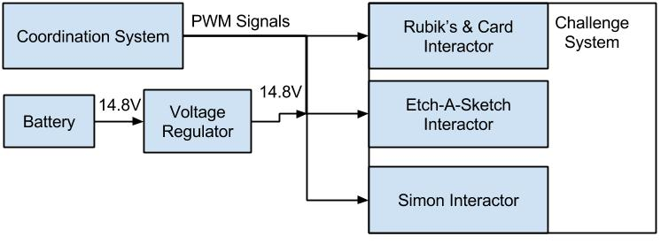

**Fig. 5**: Decomposition of Challenge System for Roadie.

The challenge system is responsible for completing all the challenges listed in [1]. This system includes a Rubik’s & Card interactor, an Etch-A-Sketch interactor and a Simon interactor.

Interacting with the Rubik’s cube means that Roadie will attempt to turn one row of the Rubik’s cube 180 degrees. Roadie will be able to positively identify the Rubik’s cube and position itself over the Rubik’s cube. Interacting with Simon means that Roadie will play Simon for 15 seconds, correctly identifying and pressing the illuminated segments. Interacting with the Etch-A-Sketch means that Roadie will successfully draw “IEEE” on the Etch-A-Sketch. Interacting with the playing card means that Roadie will successfully pick up a playing card and carry it across the finish line.

### **Assumptions**

It is assumed that all challenges will be exactly as described in [1]. Furthermore, it is assumed that all of the Challenges will perform as expected. That is to say that it is assumed that the Etch-A-Sketch knobs will perform normally. They will not have encountered unexpected wear during repeated competition rounds. Furthermore, the Rubik’s cube will be able to be rotated without an extraordinary amount of effort. If the Rubik’s cube requires more effort to be twisted than expected, Roadie will be unable to twist the cube. If the segments on Simon do not illuminate properly after multiple course rounds, Roadie will be unable to properly identify Simon.

It is assumed that Roadie will operate in the competition area shown in **Fig. 7**.

### **Dependencies**

The Challenge system is wholly dependent upon the Coordination system. The Coordination system notifies the Challenge system as to what challenge it has arrived at. From here, the Challenge system will determine which interactor to activate. Without notification from the Coordination system, the Challenge system will be unable to perform its task. Furthermore, the Challenge system relies on the challenges being exactly as described as laid forth in [1].

### **Constraints**

The Challenge system is constrained by the clock speed and memory in the microcontrollers. The Challenge system must be able to coincide with the code and logic from the other systems. Additionally, all hardware being used by the Challenge system must fit on the chassis in a manner in which it will not interfere with the other systems. The Challenge system must abide by all rules in regulations laid forth in [1].

## **Requirements**

This section details the requirements placed on the challenge system. Requirements in this section include how the system will interact with each individual challenge, and what the expected behavior is during interaction.

### **Simon Interactor**

CHA 1 The system shall play the Simon Carabiner.

CHA 2 The system shall play the Simon Carabiner for 15 seconds.

CHA 3 The system shall initiate the Simon Carabiner by pressing the start button.

CHA 4 The system shall correctly identify when the blue segment is illuminated on the Simon Carabiner.

CHA 5 The system shall correctly identify when the red segment is illuminated on the Simon Carabiner.

CHA 6 The system shall correctly identify when the yellow segment is illuminated on the Simon Carabiner.

CHA 7 The system shall correctly identify when the green segment is illuminated on the Simon Carabiner.

CHA 8 The system shall not obstruct the Simon Carabiner during play

CHA 9 The system shall respond to the last color in the Simon sequence within 5 seconds.

CHA 10 The system shall stop interacting with Simon after 15 seconds.

### **Rubik’s Interactor**

CHA 11 The system shall twist one row of a Rubik’s Cube 180 degrees within 10 seconds of entering the Rubik’s Cube state.

CHA 12 The system shall not obstruct the Rubik’s Cube during play.

CHA 13 The system shall stop interacting with the Rubik’s cube after twisting one row 180 degrees.

### **Etch-A-Sketch and Card Interactor**

CHA 14 The system shall draw “IEEE” on the pocket Etch-A-Sketch within 1 minute of entering the Etch-A-Sketch state.

CHA 15 The system shall use block letters for drawing “IEEE”.

CHA 16 The system shall draw “IEEE” large enough to be visible from a distance of 3 feet.

CHA 17 The system shall not obstruct the pocket Etch-A-Sketch during play.

CHA 18 The system shall stop interacting with the Etch-A-Sketch after drawing “IEEE” on the Etch-A-Sketch.

CHA 19 The system shall collect a single Bicycle brand standard playing card as shown in **Fig. 11**

CHA 20 The system shall carry playing card across finish line.

CHA 21 The system shall keep the card in a usable condition.

## **Use Cases**

The following use cases demonstrate the intended operations of the Challenge system of Roadie. The use cases outline the intended sequence of events as well as the procedures that will be followed in the event of a system failure.

Note: “*” indicates at any given time, during the use case.

### **Use Case 1: Simon Carabiner Challenge**

Scope: Roadie

Level: User goal

Primary Actors: Roadie

**Stakeholders & Interests**

* **Team AWTY**  - as the development team for Roadie, Roadie’s performance in the challenge will reflect directly back upon them.
* **Dr. Barott, Dr. Seker and Mr. Jorge Torres –** as customers of Team AWTY, there is an expectation that Roadie will compete successfully in the challenge.
* **ERAU –** the system represents the quality of the education at the University as well as the technical ability of the sponsors and the department.
* **ECSSE Department –** direct sponsor of Team AWTY expects Roadie to compete in and complete the challenge to the best of its abilities.
* **IEEE –** competition sponsor expects Team AWTY to conduct themselves in a manner befitting of a professional organization as well as to demonstrate innovate solutions to technical challenges.

**Preconditions**

* Roadie has reached the Simon Carabiner challenge zone.

**Postconditions**

* Roadie completes playing Simon Carabiner for 15 seconds.

**Main Success Scenario**

1. Roadie aligns itself up with the Simon Carabiner as described in Use Case: Arrival at Challenge Zone.
2. Roadie pushes the start button located on the Simon Carabiner.
3. Roadie correctly identifies which colors and order the Simon Carabiner has lit up.
4. Roadie pushes each button in the order at which the Simon Carabiner has lit up.
5. Roadie repeats steps 4 and 5 until 15 seconds have passed.

**Extensions (Alternate Flows)**

*a. Roadie fails to respond or correctly push buttons in order to where Simon signals the failure sound.

1. Roadie shall proceed to the next challenge zone or finish line if this challenge zone is the last challenge zone.

.

**Frequency of Occurrence**

This use case will occur every time Roadie reaches and identifies the challenge to be the Simon Carabiner challenge. During the competition this shall occur three times due to there being three rounds for each robot that is entered and this challenge shall occur once per round.

### **Use Case 2: Pocket Etch-A-Sketch Challenge**

Scope: Roadie

Level: User goal

Primary Actors: Roadie

**Stakeholders & Interests**

* **Team AWTY**  - as the development team for Roadie, Roadie’s performance in the challenge will reflect directly back upon them.
* **Dr. Barott, Dr. Seker and Mr. Jorge Torres –** as customers of Team AWTY, there is an expectation that Roadie will compete successfully in the challenge.
* **ERAU –** the system represents the quality of the education at the University as well as the technical ability of the sponsors and the department.
* **ECSSE Department –** direct sponsor of Team AWTY expects Roadie to compete in and complete the challenge to the best of its abilities.
* **IEEE –** competition sponsor expects Team AWTY to conduct themselves in a manner befitting of a professional organization as well as to demonstrate innovate solutions to technical challenges.

**Preconditions**

* Roadie has arrived at the pocket Etch-A-Sketch challenge zone.

**Postconditions**

* Roadie completes drawing “IEEE” using the pocket Etch-A-Sketch.

**Main Success Scenario**

1. Roadie aligns itself up with the Etch-A-Sketch as described in Use Case: Arrival at Challenge Zone.
2. Roadie twists the two knobs to draw “IEEE” in block letters on the pocket Etch-A-Sketch.

**Extensions (Alternate Flows)**

*a. Roadie fails to draw “IEEE” on the Etch-A-Sketch.

1. Finishes the part that is executing and proceeds to the next challenge zone or finish line if this challenge zone is the last challenge zone.

**Frequency of Occurrence**

This use case will occur every time Roadie reaches and identifies the challenge to be the pocket Etch-A-Sketch challenge. During the competition this shall occur three times due to there being three rounds for each robot that is entered and this challenge shall occur once per round.

### **Use Case 3: Rubik’s Cube Challenge**

Scope: Roadie

Level: User goal

Primary Actors: Roadie

**Stakeholders & Interests**

* **Team AWTY**  - as the development team for Roadie, Roadie’s performance in the challenge will reflect directly back upon them.
* **Dr. Barott, Dr. Seker and Mr. Jorge Torres –** as customers of Team AWTY, there is an expectation that Roadie will compete successfully in the challenge.
* **ERAU –** the system represents the quality of the education at the University as well as the technical ability of the sponsors and the department.
* **ECSSE Department –** direct sponsor of Team AWTY expects Roadie to compete in and complete the challenge to the best of its abilities.
* **IEEE –** competition sponsor expects Team AWTY to conduct themselves in a manner befitting of a professional organization as well as to demonstrate innovate solutions to technical challenges.

**Preconditions**

* Roadie has arrived at the Rubik’s Cube challenge zone.

**Postconditions**

* Roadie twisted a row of the Rubik’s Cube 180 degrees.

**Main Success Scenario**

1. Roadie aligns itself up with the Rubik’s Cube as described in Use Case: Arrival at Challenge Zone.
2. Roadie twist one of the rows of Rubik’s Cube 180 degrees.

**Extensions (Alternate Flows)**

*a. Roadie fails to twist the Rubik’s Cube 180 degrees.

1. Roadie will retry the challenge.

2. Roadie will process to the next challenge zone or finish line if this challenge zone is the last challenge zone.

**Frequency of Occurrence**

This use case will occur every time Roadie reaches and identifies the challenge to be the Rubik’s Cube challenge. During the competition this shall occur three times due to there being three rounds for each robot that is entered and this challenge shall occur once per round.

### **Use Case 4: Playing Card Challenge**

Scope: Roadie

Level: User goal

Primary Actors: Roadie

**Stakeholders & Interests**

* **Team AWTY**  - as the development team for Roadie, Roadie’s performance in the challenge will reflect directly back upon them.
* **Dr. Barott, Dr. Seker and Mr. Jorge Torres –** as customers of Team AWTY, there is an expectation that Roadie will compete successfully in the challenge.
* **ERAU –** the system represents the quality of the education at the University as well as the technical ability of the sponsors and the department.
* **ECSSE Department –** direct sponsor of Team AWTY expects Roadie to compete in and complete the challenge to the best of its abilities.
* **IEEE –** competition sponsor expects Team AWTY to conduct themselves in a manner befitting of a professional organization as well as to demonstrate innovate solutions to technical challenges.

**Preconditions**

* Roadie has arrived at the card challenge zone.

**Postconditions**

* Roadie has picked up a single playing card.

**Main Success Scenario**

1. Roadie aligns itself up with the playing card as described in Use Case: Arrival at Challenge Zone.
2. Roadie picks up a single playing card.
3. Roadie continues to carry the playing card that was picked up.

**Extensions (Alternate Flows)**

*a. Roadie fails to pick up a playing card.

1. Roadie shall proceed to the next challenge zone or finish line if this challenge zone is the last challenge zone.

**Frequency of Occurrence**

This use case will occur every time Roadie reaches and identifies the challenge to be the playing card challenge. During the competition this shall occur three times due to there being three rounds for each robot that is entered and this challenge shall occur once per round.

## **Sequence Diagrams**

The following sequence diagrams demonstrate the sequence of events Roadie shall take in order to complete each challenge zone.

## **Use Case 1: Simon Carabiner Challenge**

For the Use Case: Simon Carabiner Challenge Sequence Diagram as shown in **Fig. 8** below shows how Roadie will communicate with the arm mechanism in order to play Simon Says for 15 seconds.

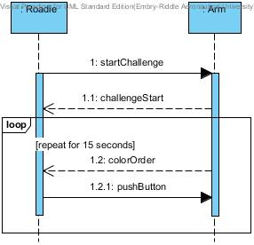

**Fig. 8:** Use Case: Simon Carabiner Challenge Sequence Diagram

## **Use Case 2: Pocket Etch-A-Sketch Challenge**

For the Use Case: Pocket Etch-A-Sketch Challenge Sequence Diagram as shown in **Fig. 9** below shows how Roadie shall communicate with the arm mechanism to draw “IEEE” on the Etch-A-Sketch.

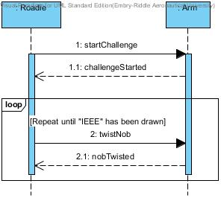

**Fig. 9:** Use Case: Pocket Etch-A-Sketch Sequence Diagram

## **Use Case 3: Rubik’s Cube Challenge**

For the Use Case: Rubik’s Cube Challenge Sequence Diagram as shown in **Fig. 10** below shows how Roadie shall communicate with the arm mechanism to twist one of the rows of the Rubik’s Cube 180 degrees to complete the challenge.

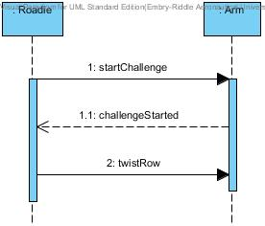

**Fig. 10:** Use Case: Rubik’s Cube Challenge

## **Use Case 4: Playing Card Challenge**

For the Use Case: Playing Card Challenge Sequence Diagram as shown in **Fig. 11** below shows how Roadie shall communicate with the arm mechanism to pick up a playing card and carry it to the finish line.

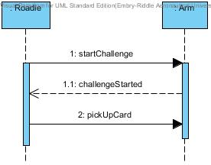

**Fig. 11:** Use Case: Playing Card Challenge Sequence Diagram

## **Traceability Matrix**

The requirements traceability matrix for the Challenge system is shown in **Table 3** below.

|  |  |  |  |
| --- | --- | --- | --- |
| Previous Requirement Number | Previous Requirement Text | New Requirement Number | Fulfillment Justification |
| 3.3.3 | The system shall play the Simon Carabiner. | CHA 1 | The requirement has not been changed from the previous version |
| 3.3.3.1 | The system shall play the Simon Carabiner for 15 seconds. | CHA 2 | The requirement has not been changed from the previous version |
| 3.3.3.2 | The system shall initiate the Simon Carabiner by pressing the start button. | CHA 3 | The requirement has not been changed from the previous version |
| 3.3.3.3 | The system shall correctly sense color blue [exact RGB values TBD] when illuminated on the Simon Carabiner. | CHA 4 | Previous requirement stated that the system would identify the colors on the Simon Carabiner based upon RGB values. This deals more with implementation rather than functionality, as such the requirements were changed to state that the system will correctly identify each color on the Simon Carabiner when it is illuminated without implicating the method for doing so |
| 3.3.3.4 | The system shall correctly sense color red [exact RGB values TBD] when illuminated on the Simon Carabiner. | CHA 5, | Previous requirement stated that the system would identify the colors on the Simon Carabiner based upon RGB values. This deals more with implementation rather than functionality, as such the requirements were changed to state that the system will correctly identify each color on the Simon Carabiner when it is illuminated without implicating the method for doing so |
| 3.3.3.5, | The system shall correctly sense color yellow [exact RGB values TBD] when illuminated on the Simon Carabiner. | CHA 6 | Previous requirement stated that the system would identify the colors on the Simon Carabiner based upon RGB values. This deals more with implementation rather than functionality, as such the requirements were changed to state that the system will correctly identify each color on the Simon Carabiner when it is illuminated without implicating the method for doing so |
| 3.3.3.6 | The system shall correctly sense color green [exact RGB values TBD] when illuminated on the Simon Carabiner. | CHA 7 | Previous requirement stated that the system would identify the colors on the Simon Carabiner based upon RGB values. This deals more with implementation rather than functionality, as such the requirements were changed to state that the system will correctly identify each color on the Simon Carabiner when it is illuminated without implicating the method for doing so |
| 3.3.3.7 | The system shall not obstruct the Simon Carabiner during play. | CHA 8 | The requirement has not been changed from the previous version |
| 3.3.3.8 | The system shall respond to the last color in the Simon sequence within [TBD] amount of time. | CHA 9 | It has been determined that the system should respond to the last color in the Simon sequence within 5 seconds. This cuts down on overall completion time of the robot and makes the system more efficient |
| New | Did not exist previously | CHA 10 | This requirement has been added to ensure that the system will stop interacting with the Simon challenge after the Simon challenge has been completed. |
| 3.3.4 | The system shall twist one row of a Rubik’s Cube 180 degrees. | CHA 11 | The new requirement added a time limit of 10 seconds for the system to start and compete the challenge. This ensures that there is not wasted time when competing the challenged and the robot can compete the course faster. |
| 3.3.4.1 | The system shall not obstruct the Rubik’s Cube during play. | CHA 12 | The requirement has not been changed from the precious version. |
| New | Did not exist previously | CHA 13 | The requirement has been added to ensure that the system will stop interacting with the Rubik’s cube after the Rubik’s cube challenge has successfully been completed. |
| 3.3.5 | The system shall draw “IEEE” on the pocket Etch-A-Sketch. | CHA 14 | The new requirement added a time limit of 1 minute for the system to start and compete the challenge. This ensures that there is not wasted time when competing the challenged and the robot can compete the course faster. |
| 3.3.5.1 | The system shall use [Font and Size TBD] for drawing “IEEE”. | CHA 15 | Previously the IEEE had not given a specific font for drawing. Since the previous version, they have specified that block lettering is the font to be used when drawing “IEEE” on the pocket Etch-A-Sketch |
| New | Did not exist previously | CHA 16 | This requirement has been added to ensure that the “IEEE” on the Etch-A-Sketch will be visible to the judges. |
| 3.3.5.2 | The system shall not obstruct the pocket Etch-A-Sketch during play. | CHA 17 | The requirement has not been changed from the previous version. |
| New | Did not exist previously | CHA 18 | This requirement has been added to ensure that the system will stop interacting with the Etch-A-Sketch once the Etch-A-Sketch challenge has been completed. |
| 3.3.6 | The system shall collect a single playing card [Exact deck TBD]. | CHA 19 | The new requirement has been modified to reflect the exact model of the playing card as determined by the IEEE. The card will be a Bicycle brand standard paying card. |
| 3.3.6.1 | The system shall carry playing card across finish line. | CHA 20 | The requirement has not been changed from the previous version |
| 3.3.6.2 | The system shall keep the card in a usable condition. | CHA 21 | The requirement has not changed from the previous version. |

**Table 3**: Requirements traceability for Challenge system.

# **Decomposition of Movement System**

The following section describes the architecture, requirements, use cases, sequence diagrams and requirements traceability of the movement system.

## **Subsystem Architecture**

**Fig. 6** shows the decomposition of Roadie’s movement System into major components.

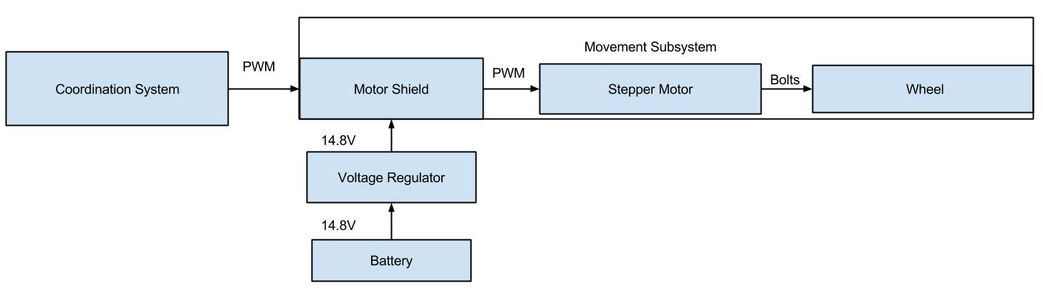

**Fig. 6**: Decomposition of Movement System Roadie.

The Movement system for Roadie consists of the drive motors, wheels and the chassis. This system is responsible for interpreting the movement commands sent to it from the Coordination system. In turn, the Movement system will advance the chassis to the specified location.

### **Assumptions**

It is assumed that the competition area will be as shown in **Fig. 7**. The movement system has been calibrated to respond to the surfaces laid out in the aforementioned figure. If the surface is different from what is described, there is no guarantee that Roadie will be able to correctly move. It is also assumed that the Movement system will be able to interpret all of the commands originating from the Coordination system. If the Movement system is unable to do so, Roadie will not move as expected.

### **Dependencies**

The Movement system is purely dependent upon the Coordination system for the direction and distance to move Roadie. The Movement system also depends on the environment it is placed in being free of obstacles or other movement inhibitors. Furthermore, the environment which Roadie is placed in must be the same as the competition area as shown in **Fig. 7**. Roadie has been constructed to work with this course format and no other.

One problem arising from dependency is that the system will fail to move. If the Movement system is unable to get information from the Coordination system, Roadie will be unable to move, representing a total system failure.

### **Constraints**

All of the code and logic for the Movement system must fit within the space allotted on the microcontroller. Furthermore, the speed at which the code can run is constrained by the clock speed on the microcontroller. The Movement system may only move as fast as the motors that have been selected to drive Roadie. All components in the Movement system must comply with all rules and regulations set forth in [1].

## **Requirements**

This section details the requirements placed on the movement system. Requirements in this section include how the chassis shall behave as well as how the system shall move.

### **Chassis Requirements**

MOV 1 The system size shall be no greater than 1ft. x 1ft. x 1ft. within the starting area and the finishing area.

MOV 2 The system shall operate for a minimum of 30 minutes when the power source starts with a full charge.

MOV 3 The system shall have an easily accessible power switch.

MOV 4 The system shall maintain contact with the competition area’s surface at all times.

### **Movement Requirements**

MOV 5 The system shall move in the competition area shown in **Fig. 7**.

MOV 6 The system shall move from the starting area to the first challenge location along the guidance tape.

MOV 7 The system shall move from the first challenge location to the second challenge location along the guidance tape.

MOV 8 The system shall move from the second challenge location to the third challenge location along the guidance tape.

MOV 9 The system shall move from third challenge location to the fourth challenge location along the guidance tape.

MOV 10 The system shall move from the fourth challenge location to the finish line along the guidance tape.

MOV 11 The system shall move at a pace sufficient to fully complete the course within five minutes.

MOV 12 The system shall visit all challenge locations before crossing the finish line.

## **Use Cases**

The following use cases demonstrate the intended operations of the Movement system of Roadie. The use cases outline the intended sequence of events as well as the procedures that will be followed in the event of a system failure.

Note: “*” indicates at any given time, during the use case.

### **Use Case 1: Dynamic Line Following**

Scope: Roadie

Level: User goal

Primary Actors: Roadie

**Stakeholders & Interests**

* **Team AWTY**  - as the development team for Roadie, Roadie’s performance in the challenge will reflect directly back upon them.
* **Dr. Barott, Dr. Seker and Mr. Jorge Torres –** as customers of Team AWTY, there is an expectation that Roadie will compete successfully in the challenge.
* **ERAU –** the system represents the quality of the education at the University as well as the technical ability of the sponsors and the department.
* **ECSSE Department –** direct sponsor of Team AWTY expects Roadie to compete in and complete the challenge to the best of its abilities.
* **IEEE –** competition sponsor expects Team AWTY to conduct themselves in a manner befitting of a professional organization as well as to demonstrate innovate solutions to technical challenges.

**Preconditions**

* Roadie has left the starting area or has just finished a challenge and has entered the line following state.

**Postconditions**

* Roadie arrives at the next challenge area, right or left turn, an intersection, or reaches the finish line after completing all of the challenges.

**Main Success Scenario**

1. Roadie moves forward on the line.
2. Roadie continues makes adjustments to stay on the line.
3. Repeat steps one and two until reaching a challenge area, finish line, right or left turn, or an intersection.

**Extensions (Alternate Flows)**

*a. Roadie shall return to the last know location on the play board before the error occurred

1. Roadie shall continue on from the last know location.

**Frequency of Occurrence**

This use case will occur every time Roadie is in the line following state during the navigation between the starting area and the next challenge area or finish line. During the competition this shall occur three times due to there being three rounds for each robot that is entered.

### **Use Case 2: Right Turn**

Scope: Roadie

Level: User goal

Primary Actors: Roadie

**Stakeholders & Interests**

* **Team AWTY**  - as the development team for Roadie, Roadie’s performance in the challenge will reflect directly back upon them.
* **Dr. Barott, Dr. Seker and Mr. Jorge Torres –** as customers of Team AWTY, there is an expectation that Roadie will compete successfully in the challenge.
* **ERAU –** the system represents the quality of the education at the University as well as the technical ability of the sponsors and the department.
* **ECSSE Department –** direct sponsor of Team AWTY expects Roadie to compete in and complete the challenge to the best of its abilities.
* **IEEE –** competition sponsor expects Team AWTY to conduct themselves in a manner befitting of a professional organization as well as to demonstrate innovate solutions to technical challenges.

**Preconditions**

* Roadie reaches a right turn and exits the line following state.

**Postconditions**

* Roadie makes a 90 degree turn to the right and enters the line following state.

**Main Success Scenario**

1. Roadie arrives at a right turn.
2. Roadie continues to move forward until the center of Roadie is at the right turn.
3. Roadie checks to see if the line continues forwards and turns right then set a flag if the line continues forward.
4. Roadie turn to the right 90 degrees.
5. Roadie enters the line following state and begins moving forward again.

**Extensions (Alternate Flows)**

*a. Roadie makes a wrong turn.

1. Roadie detects no line.

2. Roadie shall reverse the turn and continue turning in the opposite direction.

**Frequency of Occurrence**

This use case will occur every time Roadie reaches a right turn during the navigation between the starting area and the next challenge area or finish line. During the competition this shall occur three times due to there being three rounds for each robot that is entered.

### **Use Case 3: Left Turn**

Scope: Roadie

Level: User goal

Primary Actors: Roadie

**Stakeholders & Interests**

* **Team AWTY**  - as the development team for Roadie, Roadie’s performance in the challenge will reflect directly back upon them.
* **Dr. Barott, Dr. Seker and Mr. Jorge Torres –** as customers of Team AWTY, there is an expectation that Roadie will compete successfully in the challenge.
* **ERAU –** the system represents the quality of the education at the University as well as the technical ability of the sponsors and the department.
* **ECSSE Department –** direct sponsor of Team AWTY expects Roadie to compete in and complete the challenge to the best of its abilities.
* **IEEE –** competition sponsor expects Team AWTY to conduct themselves in a manner befitting of a professional organization as well as to demonstrate innovate solutions to technical challenges.

**Preconditions**

* Roadie reaches a left turn and exits the line following state.

**Postconditions**

* Roadie makes a 90 degree turn to the left and enters to the line following state.

**Main Success Scenario**

1. Roadie arrives at a left turn.
2. Roadie continues to move forward until the center of Roadie is at the left turn.
3. Roadie checks to see if the line continues forwards and turns right left set a flag if the line continues forward.
4. Roadie turn to the left 90 degrees.
5. Roadie enters the line following state and begins moving forward again.

**Extensions (Alternate Flows)**

*a. Roadie makes a wrong turn.

1. Roadie detects no line.

2. Roadie shall reverse the turn and continue turning in the opposite direction.

**Frequency of Occurrence**

This use case will occur every time Roadie reaches a left turn during the navigation between the starting area and the next challenge area or finish line. During the competition this shall occur three times due to there being three rounds for each robot that is entered.

### **Use Case 4: Intersection**

Scope: Roadie

Level: User goal

Primary Actors: Roadie

**Stakeholders & Interests**

* **Team AWTY**  - as the development team for Roadie, Roadie’s performance in the challenge will reflect directly back upon them.
* **Dr. Barott, Dr. Seker and Mr. Jorge Torres –** as customers of Team AWTY, there is an expectation that Roadie will compete successfully in the challenge.
* **ERAU –** the system represents the quality of the education at the University as well as the technical ability of the sponsors and the department.
* **ECSSE Department –** direct sponsor of Team AWTY expects Roadie to compete in and complete the challenge to the best of its abilities.
* **IEEE –** competition sponsor expects Team AWTY to conduct themselves in a manner befitting of a professional organization as well as to demonstrate innovate solutions to technical challenges.

**Preconditions**

* Roadie reaches an intersection and exits the line following state.

**Postconditions**

* Roadie makes a left or right turn depending on the intersection and sets a flag for which way Roadie turned and enters the line following state.

**Main Success Scenario**

1. Roadie arrives at an intersection.
2. Roadie checks the intersection flag to decide which way to turn left or right.
3. Roadie moves forward until Roadie in centered above the intersection.
4. Roadie makes a turn based on the intersection flag.
5. Roadie enters the line following state.

**Extensions (Alternate Flows)**

*a. Roadie makes a wrong turn.

1. Roadie detects no line.

2. Roadie shall reverse the turn and continue turning in the opposite direction.

**Frequency of Occurrence**

This use case will occur every time Roadie reaches an intersection during the navigation between the starting area and the next challenge area or finish line. During the competition this shall occur three times due to there being three rounds for each robot that is entered.

## **Sequence Diagrams**

The following sequence diagrams demonstrate the sequence of events Roadie shall take in order to move around the playing field.

## **Use Case 1: Dynamic Line Following**

For the Use Case: Dynamic Line Following Sequence Diagram as shown in **Fig. 13** below shows how Roadie shall communicate with the movement system in order to adjust itself above the line and follow the line until reach a point of interest.

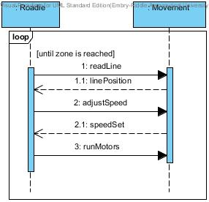

**Fig. 13:** Use Case: Dynamic Line Following Sequence Diagram

## **Use Case 2: Right Turn Sequence**

For the Use Case: Right Turn Sequence Diagram as shown in **Fig. 14** below shows how Roadie shall communicate with the movement system in order to make 90 degree turn to the right and re-enter the line following state.

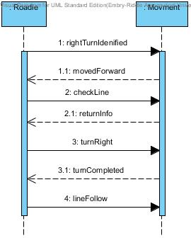

**Fig. 14:** Use Case: Right Turn Sequence Diagram

## **Use Case 3: Left Turn Sequence**

For the Use Case: Left Turn Sequence Diagram as shown in **Fig. 15** below shows how Roadie shall communicate with the movement system in order to make 90 degree turn to the left and re-enter the line following state.

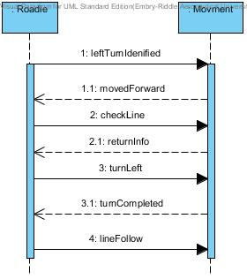

**Fig. 15:** Use Case: Left Turn Sequence Diagram

## **Use Case 4: Intersection Sequence Diagram**

For the Use Case: Intersection Sequence Diagram as shown in **Fig. 16** below shows how Roadie shall communicate with the movement system in order to decide which way to turn and then re-enter the line following state.

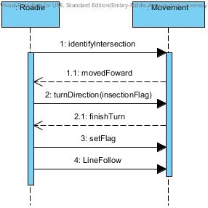

**Fig. 16:** Use Case: Intersection Sequence Diagram

## **Traceability Matrix**

Requirements traceability for Movement system is shown in **Table 4** below.

|  |  |  |  |
| --- | --- | --- | --- |
| Previous Requirement Number | Previous Requirement Text | New Requirement Number | Fulfillment Justification |
| 4.1.1 | The system size shall be no greater than 1ft. x 1ft. x 1ft. within the starting area and the finishing area. | MOV 1 | The requirement has not changed from the previous version. |
| 4.2.1 | The system shall operate for a minimum of [TBD] minutes when the power source starts with a full charge. | MOV 2 | Since previous versions it has been determined that the system must operate for at least 30 minutes on a full battery. In order to be considered operational the system must be able to move accurately and quickly enough to complete all challenges within the time limit. |
| 4.3.1 | The system shall have an easily accessible power switch. | MOV 3 | The requirement has not changed from the previous version. |
| 4.3.3 | The system shall maintain contact with the competition area’s surface at all times. | MOV 4 | The requirement has not changed from the previous version. |
| 3.1.1 | The system shall move in the competition area shown in **Fig. 7**. | MOV 5 | The requirement has not changed from the previous version. |
| 3.1.2 | The system shall move from the starting area to the Simon Carabiner along the Scotch Blue Painter’s tape (guidance tape). | MOV 6 | It is not guaranteed that it is efficient or even possible to define which challenge zone the robot will enter in what order. Therefore the new requirement states that after leaving the starting line the system will navigate to the first challenge zone it comes across by following the guidance tape. |
| 3.1.3 | The system shall move from the Simon Carabiner to the pocket Etch-a-Sketch along the guidance tape. | MOV 7 | It is not guaranteed that it is efficient or even possible to define which challenge zone the robot will enter in what order. Therefore the new requirement states that after leaving the first challenge zone, the system will navigate to the next challenge zone it finds on the guidance tape which will become the second challenge zone for that run through the course |
| 3.1.4 | The system shall move from the pocket Etch-a-Sketch to the Rubik’s Cube along the guidance tape. | MOV 8 | It is not guaranteed that it is efficient or even possible to define which challenge zone the robot will enter in what order. Therefore the new requirement states that after leaving the second challenge zone, the system will navigate to the next challenge zone it finds on the guidance tape which will become the third challenge zone for that run through the course |
| 3.1.5 | The system shall move from the Rubik’s Cube to the deck of playing cards along the guidance tape. | MOV 9 | It is not guaranteed that it is efficient or even possible to define which challenge zone the robot will enter in what order. Therefore the new requirement states that after leaving the third challenge zone, the system will navigate to the next challenge zone it finds on the guidance tape which will become the fourth challenge zone for that run through the course |
| 3.1.6 | The system shall move from the deck of playing cards to the finish line along the guidance tape. | MOV 10 | The previous requirement implied that the fourth challenge zone would always be the deck of playing cards, the new requirement allows the for the robot to navigate along the guidance tape to the finish after completing all four challenges even if the fourth challenge is not the deck of cards |
| New | Did not exist previously | MOV 11 | This requirement has been added to ensure that the system will be able to complete the course in the time allotted. |
| New | Did no exist previously | MOV 12 | This requirement has been added to ensure that the system will correctly traverse the course before crossing the finish line. |

**Table 4:** Requirements traceability for Movement system.

# **Glossary**

The glossary contains definitions of words and phrases used throughout this document.

|  |  |  |
| --- | --- | --- |
| Entry | Definition | Aliases |
| Align | The system will position itself so the appendages can properly reach the challenges. |  |
| Autonomous | Undertaken or carried on without outside control [2]. |  |
| Challenge Zone | The 1ft. x 1ft. areas where each of the challenges will be played along the course. |  |
| Competition Area | The competition area is the plywood board where the competition is being held on. The system must maintain contact with the board at all times. |  |
| Course Round | A span of five minutes during which the system is expected to complete the 4 challenges [1]. |  |
| Finish Line | The finish line is the ending point of the competition. It is the point where the Scotch Blue Painter’s Tape comes to the final “T” shape on the course [1]. It is marked as FINISH in **Fig. 7**. |  |
| First Challenge Location | The challenge location whose distance along the guidance tape is the shortest from the starting area. |  |
| Fourth Challenge Location | The challenge location whose distance along the guidance tape is the shortest from the third challenge location. |  |
| Institute of Electrical and Electronics Engineers | “IEEE is the world's largest professional association dedicated to advancing technological innovation and excellence for the benefit of humanity” [4]. That being said, IEEE is not only composed of electronic and electrical engineers as the name might suggest. Other types of members include computer scientists, software developers and even some doctors. | IEEE |
| Obstruct | SoutheastCon rules state that the system cannot obstruct any obstacle [1]. |  |
| Playing Card | Bicycle brand, standard bridge sized playing card as shown in **Fig. 11**. |  |
| Pocket Etch-A-Sketch | The pocket Etch-A-Sketch is a popular children’s toy with two knobs to move the cursor up and down as well as left and right. For the competition, the specific version of the pocket Etch-A-Sketch being used is SKU:FD79DD3F from Toys R Us online [7], and can be seen in **Fig. 10.** |  |
| Rubik’s Cube | The Rubik’s Cube is a puzzle game that achieved popularity in the 1980’s. For the competition, the specific version of the Rubik’s Cube being used is SKU:DAD09D9E from Toys R Us online [6], and can be seen in **Fig. 9.** |  |
| Scotch Blue Painter’s Tape | Scotch Blue is a brand of painter’s tape produced by the company 3M. For the competition, the specific model of painters tape being used is SKU: 958999 from Home Depot [8], and can be seen in **Fig. 12.** | Guidance Tape |
| Second Challenge Location | The challenge location whose distance along the guidance tape is the shortest from the first challenge location. |  |
| Sense |  |  |
| Simon Carabiner | The Simon Carabiner is another version of the game, Simon, which is an electronic version of the children’s game “Simon Says”. For the competition, the specific version of Simon being used is SKU:226CE810 from Toys R Us online [5], and can be seen in **Fig. 8.** |  |
| SoutheastCon | SoutheastCon is the annual IEEE Region 3 Technical, Professional, and Student Conference. The conference includes technical sessions, tutorials, and exhibits. Additionally, various challenges and competitions are held for students to demonstrate their technical knowledge and understanding.“IEEE Region 3 encompasses the southeastern United States and includes the states of Alabama, Florida, Georgia, areas of Indiana, Kentucky, Mississippi, North Carolina, South Carolina, Tennessee, Virginia and the country of Jamaica” [3]. |  |
| Starting Area | A one foot by one foot area on the competition area marked by Scotch Blue Painter’s tape [1]. |  |
| Third Challenge Location | The challenge location whose distance along the guidance tape is the shortest from the second challenge location. |  |
| Usable Condition | SoutheastCon rules state that the playing card must be left in a usable condition [1]. |  |

# **Appendix A**

Appendix A includes all of the requirements presented in the System Requirements Specifications for Roadie, version 1.0.0, dated 2014-09-18. The requirement text is shown, followed by changes, signified by a red strike-through. The resulting revised requirement in shown in the final column. This information is displayed in **Table** 2below:

|  |  |  |  |  |
| --- | --- | --- | --- | --- |
| Previous Requirement Number | Previous Text | Changes | Resulting Requirement Text | New Requirement Number |
| 3.1.1 | The system shall move in the competition area shown in **Fig. 7**. | N/A | The system shall move in the competition area shown in **Fig. 7**. | MOV 5 |
| 3.1.2 | The system shall move from the starting area to the Simon Carabiner along the Scotch Blue Painter’s tape (guidance tape). | The system shall move from the starting area to the ~~Simon Carabiner~~ first challenge location along the Scotch Blue Painter’s tape (guidance tape). | The system shall move from the starting area to the first challenge location along the Scotch Blue Painter’s tape (guidance tape). | MOV 6 |
| 3.1.3 | The system shall move from the Simon Carabiner to the pocket Etch-a-Sketch along the guidance tape. | The system shall move from the ~~Simon Carabiner to the pocket Etch-a-Sketch~~ first challenge location to the second challenge location along the guidance tape. | The system shall move from the first challenge location to the second challenge location along the guidance tape. | MOV 7 |
| 3.1.4 | The system shall move from the pocket Etch-a-Sketch to the Rubik’s Cube along the guidance tape. | The system shall move from the ~~pocket Etch-a-Sketch to the Rubik’s Cube~~ second challenge location to the third challenge location along the guidance tape. | The system shall move from the second challenge location to the third challenge location along the guidance tape. | MOV 8 |
| 3.1.5 | The system shall move from the Rubik’s Cube to the deck of playing cards along the guidance tape. | The system shall move from the ~~Rubik’s Cube to the deck of playing cards~~ third challenge location to the fourth challenge location along the guidance tape. | The system shall move from third challenge location to the fourth challenge location along the guidance tape. | MOV 9 |
| 3.1.6 | The system shall move from the deck of playing cards to the finish line along the guidance tape. | The system shall move from the ~~deck of playing cards~~ fourth challenge location to the finish line along the guidance tape. | The system shall move from the fourth challenge location to the finish line along the guidance tape. | MOV 10 |
| 3.1.7 | The system shall wait for red [RGB value TBD] LED in starting area to turn off before exiting the starting area. | The system shall wait for the red ~~[RGB value TBD]~~ LED in the starting area to turn off before exiting the starting area. | The system shall wait for the red LED in the starting area to turn off before exiting the starting area. | COR 5 |
| 3.2.1 | The system shall start in the starting area. | The system shall ~~start in the~~ commence operation from the starting area. | The system shall commence operation from the starting area. | COR 1 |
| 3.2.2 | The system shall progress forward along the blue guidance tape until reaching a challenge area or reaching the finish line. | N/A | The system shall progress forward along the blue guidance tape until reaching a challenge area or reaching the finish line. | COR 2 |
| 3.2.3 | The system shall identify the challenge zone and stop movement upon arrival. | The system shall identify the challenge zone ~~and stop movement~~ upon arrival. | The system shall identify the challenge zone upon arrival. | COR 3 |
| 3.3.1 | The system shall correctly identify the challenge upon arrival. | The system shall correctly identify the challenge within 10 seconds of arrival in a challenge zone. | The system shall correctly identify the challenge within 10 seconds of arrival in a challenge zone. | COR 6 |
| 3.3.1.1 | The system correctly identifies the Simon Carabiner depicted in **Fig. 8** | The system shall correctly identify the Simon Carabiner depicted in **Fig. 8** | The system shall correctly identify the Simon Carabiner depicted in **Fig. 8** | COR 6.2 |
| 3.3.1.2 | The system correctly identifies the Rubik’s Cube depicted in **Fig. 9.** | The system shall correctly identify the Rubik’s Cube depicted in **Fig. 9** | The system shall correctly identify the Rubik’s Cube depicted in **Fig. 9** | COR 6.3 |
| 3.3.1.3 | The system correctly identifies the pocket Etch-A-Sketch depicted in **Fig. 10**. | The system shall correctly identify the pocket Etch-A-Sketch depicted in **Fig. 10** | The system shall correctly identify the pocket Etch-A-Sketch depicted in **Fig. 10** | COR 6.4 |
| 3.3.1.4 | The system correctly identifies the playing cards depicted in **Fig.** [TBD]. | The system shall correctly identify the playing cards depicted in **Fig.** [TBD]. | The system shall correctly identify the playing cards depicted in **Fig.** [TBD]. | COR 6.5 |
| 3.3.2 | The system shall align with the challenge before attempting to complete the challenge. | The system shall align with the challenge if the challenge is not within 0.1 cm of the center of the leading edge of the chassis. | The system shall align with the challenge if the challenge is not within 0.1 cm of the center of the leading edge of the chassis. | COR 7 |
| 3.3.3 | The system shall play the Simon Carabiner. | N/A | The system shall play the Simon Carabiner. | CHA 1 |
| 3.3.3.1 | The system shall play the Simon Carabiner for 15 seconds. | N/A | The system shall play the Simon Carabiner for 15 seconds. | CHA 2 |
| 3.3.3.2 | The system shall initiate the Simon Carabiner by pressing the start button. | N/A | The system shall initiate the Simon Carabiner by pressing the start button. | CHA 3 |
| 3.3.3.3 | The system shall correctly sense color blue [exact RGB values TBD] when illuminated on the Simon Carabiner. | The system shall correctly sense ~~color blue [exact RGB values TBD]~~ when the blue segment is illuminated on the Simon Carabiner. | The system shall correctly sense when the blue segment is illuminated on the Simon Carabiner. | CHA 4 |
| 3.3.3.4 | The system shall correctly sense color red [exact RGB values TBD] when illuminated on the Simon Carabiner. | The system shall correctly sense ~~color blue [exact RGB values TBD]~~ when the red segment is illuminated on the Simon Carabiner. | The system shall correctly sense when the red segment is illuminated on the Simon Carabiner. | CHA 5 |
| 3.3.3.5 | The system shall correctly sense color yellow [exact RGB values TBD] when illuminated on the Simon Carabiner. | The system shall correctly sense ~~color blue [exact RGB values TBD]~~ when the yellow segment is illuminated on the Simon Carabiner. | The system shall correctly sensewhen the yellow segment is illuminated on the Simon Carabiner. | CHA 6 |
| 3.3.3.6 | The system shall correctly sense color green [exact RGB values TBD] when illuminated on the Simon Carabiner. | The system shall correctly sense ~~color blue [exact RGB values TBD]~~ when the green segment is illuminated on the Simon Carabiner. | The system shall correctly sense when the green segment is illuminated on the Simon Carabiner. | CHA 7 |
| 3.3.3.7 | The system shall not obstruct the Simon Carabiner during play. | N/A | The system shall not obstruct the Simon Carabiner during play | CHA 8 |
| 3.3.3.8 | The system shall respond to the last color in the Simon sequence within [TBD] amount of time. | The system shall respond to the last color in the Simon sequence within ~~[TBD]~~ 5 seconds ~~amount of time.~~ | The system shall respond to the last color in the Simon sequence within 5 seconds. | CHA 9 |
| 3.3.4 | The system shall twist one row of a Rubik’s Cube 180 degrees. | The system shall twist one row of a Rubik’s Cube 180 degrees within 10 seconds of starting the challenge. | The system shall twist one row of a Rubik’s Cube 180 degrees within 10 seconds of starting the challenge. | CHA 10 |
| 3.3.4.1 | The system shall not obstruct the Rubik’s Cube during play. | N/A | The system shall not obstruct the Rubik’s Cube during play. | CHA 11 |
| 3.3.5 | The system shall draw “IEEE” on the pocket Etch-A-Sketch. | The system shall draw “IEEE” on the pocket Etch-A-Sketch within 1 minute of starting the challenge. | The system shall draw “IEEE” on the pocket Etch-A-Sketch within 1 minute of starting the challenge. | CHA 12 |
| 3.3.5.1 | The system shall use [Font and Size TBD] for drawing “IEEE”. | The system shall use ~~[Font and Size TBD]~~ block letters for drawing “IEEE”. | The system shall use block letters for drawing “IEEE”. | CHA 13 |
| 3.3.5.2 | The system shall not obstruct the pocket Etch-A-Sketch during play. | N/A | The system shall not obstruct the pocket Etch-A-Sketch during play. | CHA 14 |
| 3.3.6 | The system shall collect a single playing card [Exact deck TBD]. | The system shall collect a single Bicycle brand standard playing card as shown in **Fig. 11** ~~[Exact deck TBD].~~ | The system shall collect a single Bicycle brand standard playing card as shown in **Fig. 11**. | CHA 15 |
| 3.3.6.1 | The system shall carry playing card across finish line. | N/A | The system shall carry playing card across finish line. | CHA 16 |
| 3.3.6.2 | The system shall keep the card in a usable condition. | N/A | The system shall keep the card in a usable condition. | CHA 17 |
| 4.1.1 | The system size shall be no greater than 1ft. x 1ft. x 1ft. within the starting area and the finishing area. | N/A | The system size shall be no greater than 1ft. x 1ft. x 1ft. within the starting area and the finishing area. | MOV 1 |
| 4.2.1 | The system shall operate for a minimum of [TBD] minutes when the power source starts with a full charge. | The system shall operate for a minimum of ~~[TBD]~~ 30 minutes when the power source starts with a full charge. | The system shall operate for a minimum of 30 minutes when the power source starts with a full charge. | MOV 2, COR 13 |
| 4.3.1 | The system shall have an easily accessible power switch. | N/A | The system shall have an easily accessible power switch. | MOV 3 |
| 4.3.2 | The system shall be completely autonomous after being powered on. | N/A | The system shall be completely autonomous after being powered on. | COR 12 |
| 4.3.3 | The system shall maintain contact with the competition area’s surface at all times. | N/A | The system shall maintain contact with the competition area’s surface at all times. | MOV 4 |

Table 5: Requirements imposed upon Roadie in the level one requirements.

# **Appendix B**

This appendix includes a diagram of the competition course as well as pictures of the individual challenges the system must complete. Also included is a picture of the tape that will designate the line the system must follow.

## **Competition Course**

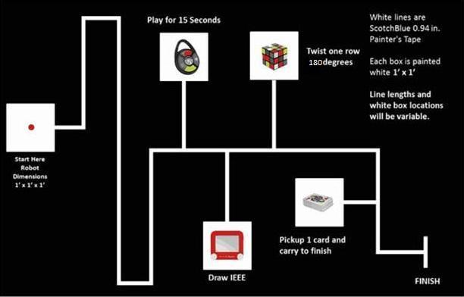The course, as shown in **Fig. 7** below, shows the rough outline of the track the system will follow, as well as what a challenge station would look like.

**Fig. 7** Competition course for SoutheastCon[1].

## **Simon Carabiner**

The Simon Carabiner, as seen in **Fig. 8** is the specific Simon game that the system will play.

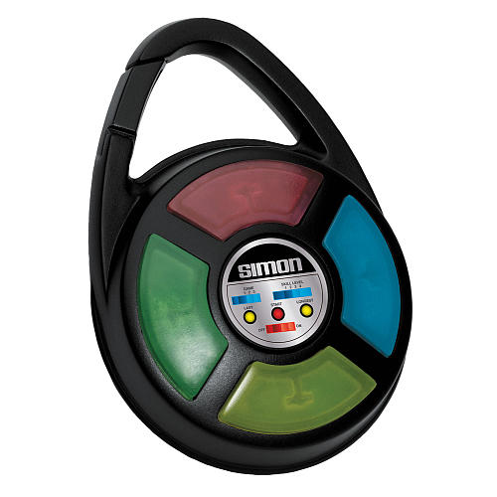

**Fig. 8:** The exact Simon Carabiner to be used during competition [5].

## **Rubik’s Cube**

The Rubik’s Cube, as seen in **Fig. 9** is the specific Rubik’s Cube that the system will play.

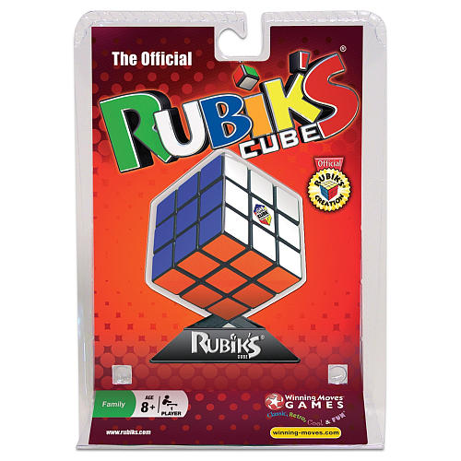

**Fig. 9:** The exact Rubik's Cube to be used during competition [6].

## **Pocket Etch-A-Sketch**

The pocket Etch-A-Sketch as shown in **Fig. 10** is the specific pocket Etch-A-Sketch the system will play.

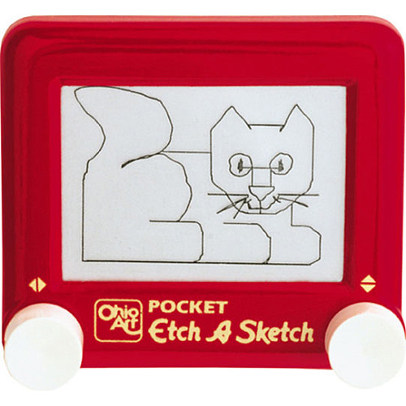

**Fig. 10:** The exact pocket Etch-A-Sketch to be used during competition [7].

## **Playing Cards**

The Bicycle Brand Standard playing cards shown in **Fig. 11** are the exact cards to be used during competition.

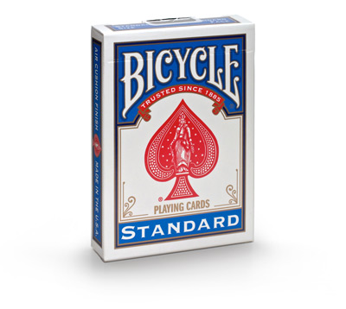

**Fig. 11:** The exact playing cards to be used during competition [9].

## **Scotch Blue Painter’s Tape**

The Scotch Blue Painter’s Tape as show in **Fig. 12** is the exact painter’s tape that will be used to designate the line the system must follow.

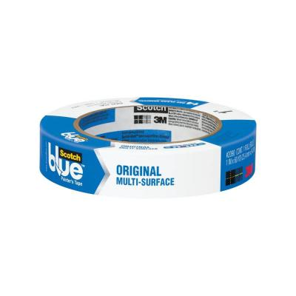

**Fig. 12:** The exact painter’s tape to be used on the course [8].

# **References**

[1] IEEE Nova Southeastern University. (2014, September 7). IEEE SoutheastCon 2015 Student Program - Hardware Competition. Retrieved September 7, 2014, from IEEE SoutheastCon 2015: http://www.ewh.ieee.org/reg/3/southeastcon2015/StudentProgram.html

[2] Rembold, U., & Fatikow, S. (1997). Autonomous Microbots. Journal of Intelligent and Robotic Systems, 19(4), 1.

[3] SoutheastCon. (n.d.). Retrieved September 13, 2014, from http://www.ewh.ieee.org/reg/3/southeastcon/

[4] "IEEE About IEEE." IEEE. N.p., n.d. Web. 12 Sept. 2014, from http://www.ieee.org/about/index.html.

[5] Simon Carabiner. (n.d.). Retrieved September 15, 2014, from http://www.toysrus.com/buy/card-puzzle-games/simon-carabiner-1850-3839349

[6] Rubik's 3x3 Cube. (n.d.). Retrieved September 16, 2014, from http://www.toysrus.com/buy/brain-teasers/rubik-s-3x3-cube-wm5027-29224016

[7] Pocket Etch A Sketch - Red. (n.d.). Retrieved September 16, 2014, from http://www.toysrus.com/buy/etch-a-sketch-doodle-pro/pocket-etch-a-sketch-red-5163-2395954

[8] 3M 0.94 in. x 60 yds. Painter's Tape-2090-24J at The Home Depot. (n.d.). Retrieved September 16, 2014, from http://www.homedepot.com/p/ScotchBlue-0-94-in-x-60-yds-Painter-s-Tape-2090-1J/100085823

[9] "Bicycle Cards." Bicycle® Standard Index Cards. Accessed November 21, 2014. http://www.bicyclecards.com/products/playing-card/bicycle-standard-index.